 

**EXPERIMENT REPORT OF ASSEMBLY LANGUAGE**

Assignment 1 Experiment1

NAME : ABID ALI

STUDENT ID :2019380141

DATE : 5/15/2021

SUBMITTED TO :PROFESSOR Yin LU

**Problem Description:**

Addition of multi-bytes BCD numbers. There are two large BCD numbers in the data segment, DATA1 and DATA2. Each number takes 5 bytes, and it is stored in little endian format (lower digit goes to lower address). Please adds DATA1 and DATA2 together, and save the result in the third variable DATA3.

The template given is given below:

.MODEL SMALL

.STACK 32

.DATA

DATA1 DB 10H,34H,56H,78H,00H

DATA2 DB 90H,88H,77H,66H,00H

DATA3 DB 00H,00H,00H,00H

.CODE

MAIN PROC FAR

; INITIALIZE DATA SEGMENT

MOV AX, @DATA

MOV DS, AX

;here is the program body

; RETURN TO DOS

MOV AX, 4C00H

INT 21H

MAIN ENDP

END MAIN

**Goal:**

Addition between two multibyte number

10H,34H,56H,78H,00H

90H,88H,77H,66H,00H

(+) -------------------------------

AOH,BCH ,CDH,DEH ,00H

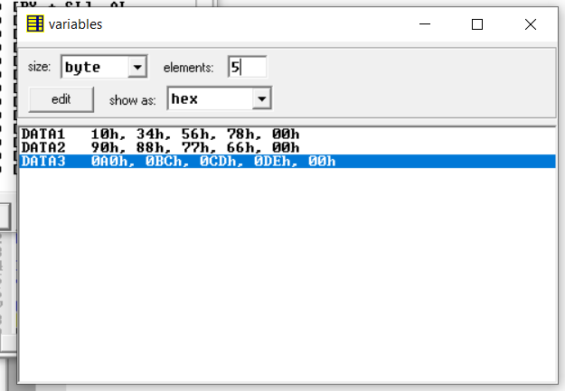

**Code:**

;========================================================

;Description: Program of Assignment 1 Experiment1

;Author:[ABID ALI][2019380141]

;Date:[2021/05/13]

;========================================================'

.MODEL SMALL

.STACK 32

.DATA

DATA1 DB 10H,34H,56H,78H,00H

DATA2 DB 90H,88H,77H,66H,00H

DATA3 DB 00H,00H,00H,00H

.CODE

MAIN PROC FAR

; INITIALIZE DATA SEGMENT

START: MOV AX, @DATA

MOV DS, AX

MOV CX,05 ;INITIALIZING CX=5 TO LOOP 5 TIMES

; here is the program body

MOV BX,OFFSET DATA1 ;WE PUT THE VALUE IN THE BX REGISTER

MOV SI,OFFSET DATA2

MOV DI,OFFSET DATA3

AGAIN: ;LOOP BODY

MOV AL,[BX]

INC BX

ADC AL,[SI]

INC SI

MOV [DI],AL

INC DI

DEC CX ;DECREMENTING THE CX EACH TIME ,TO MAKE IT A FINITE LOOP

JNZ AGAIN ;LOOP AGAIN

; RETURN TO DOS ;BACK TO DOS

MOV AX, 4C00H

INT 21H

MAIN ENDP

END MAIN

**Debugging:**

This is a new IDE for me ,I have never used it before .So,at the beginning ,I couldn’t understand the use of so many features.Eventually,after watching video and getting suggestion from my friend .I was able to solve this problem.The first problem ,I first was I didn’t know how to select more than one data.

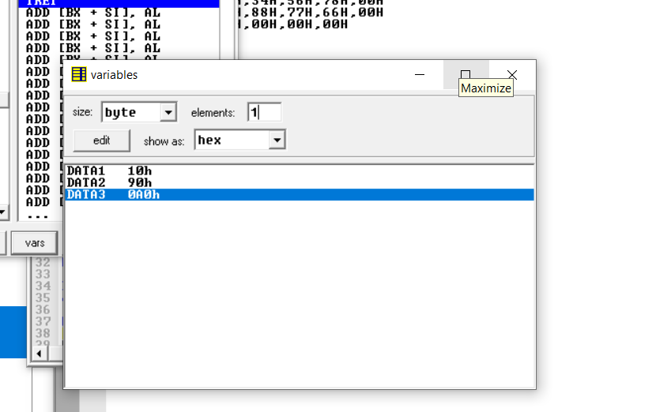

Then,I realize ,I need to click 5 elements.I thought ,I had a problem in my program.Finally,I realize the mistake.Common mistake ,I made during this project mixing different register and what register to use when.Eventually,I manage to solve the problem.

**Attachment:**

1) Experiment-1(part-1).m4v

2) Exp-1_part1.asm

**Acknowledgement:**

I complete this assignment by myself by using online videos and taking help from online.The most useful help from teacher’s hint given in question.